NOTICE OF CANCELLATION

PERSONNEL & FINANCE COMMITTEE
Members: Jim Friedman, Laura Hernandez, Kevin Kildee, and Ed Jones

TUESDAY, APRIL 2, 2019, 8:30 A.M.

1001 Partridge Drive, Ventura CA 93003
(VRSD Board Room)

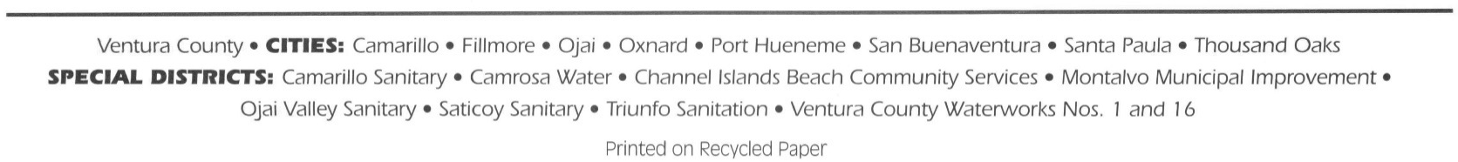
NOTICE IS HEREBY GIVEN that the Ventura Regional Sanitation District Board of Directors’ Personnel & Finance Committee meeting of April 2, 2019 is cancelled. The next meeting is scheduled for May 7, 2019.

For information or assistance, please call the Clerk of the Board at (805) 658-4642.

________________________

Juliet I. Rodriguez

Clerk of the Board

Dated: March 27, 2019

